Icosahedron
# Source: AI Source: Provided by: [Data Path: Persons Table -> ID Column: 1, Name_En Column: Motasem Essam] -> From: [ChatGPT] on [7/25/2026]
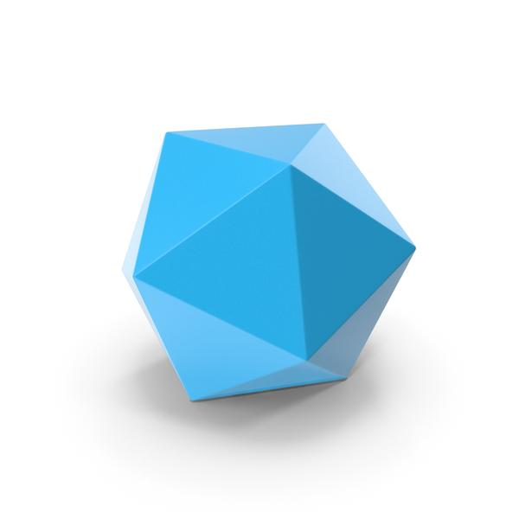
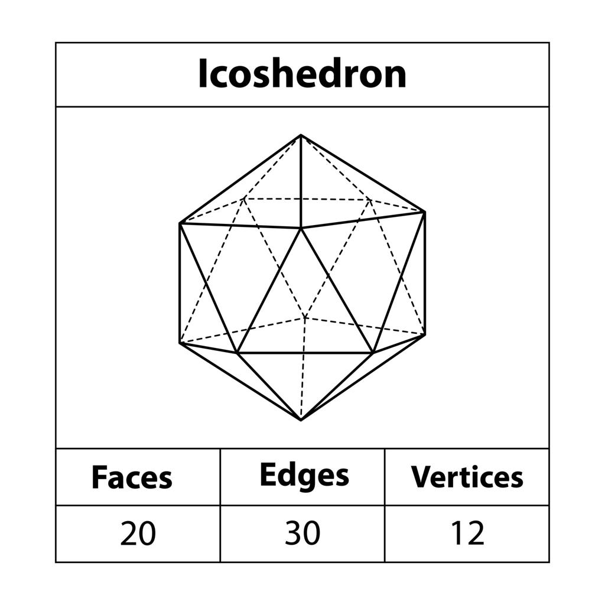
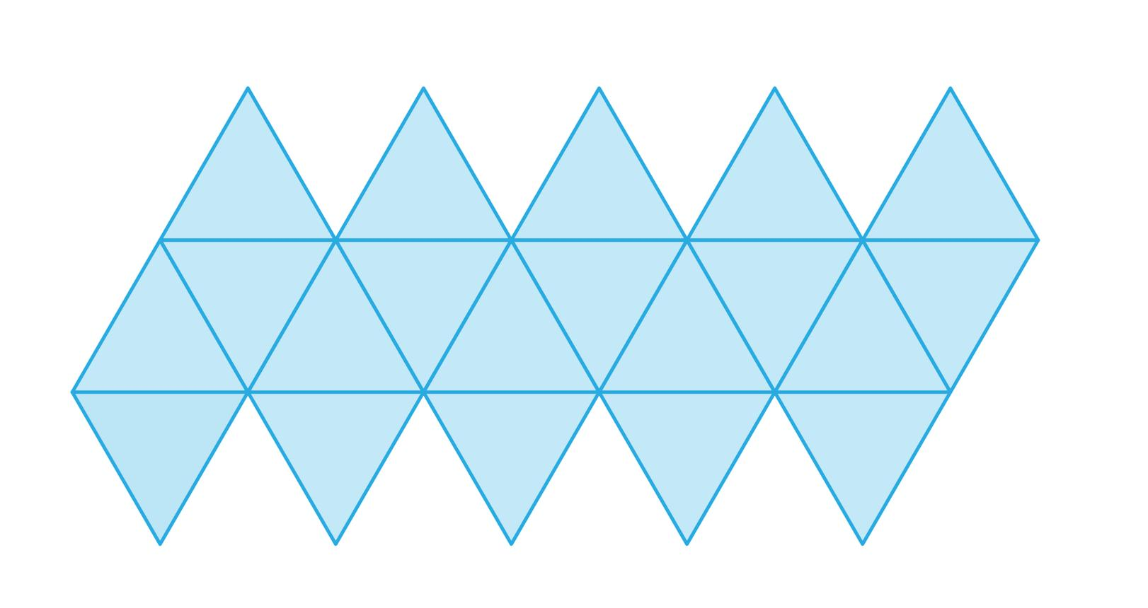

Definition
# Source: AI Source: Provided by: [Data Path: Persons Table -> ID Column: 1, Name_En Column: Motasem Essam] -> From: [ChatGPT] on [7/25/2026]
An icosahedron is a three-dimensional polyhedron with twenty faces, thirty edges, and twelve vertices. Among the five Platonic solids, the regular icosahedron has twenty congruent equilateral-triangle faces.
All thirty edges have equal lengths, and five triangular faces meet at every vertex. Its highly symmetrical structure makes it one of the most recognizable Platonic solids.
The word icosahedron comes from Greek: eikosi means twenty, and hedron means face.

Simple Definition
# Source: AI Source: Provided by: [Data Path: Persons Table -> ID Column: 1, Name_En Column: Motasem Essam] -> From: [ChatGPT] on [7/25/2026]
An icosahedron is a solid with twenty triangular faces.
For a regular icosahedron:
- Faces: 20 equilateral triangles
- Edges: 30 equal line segments
- Vertices: 12 corners
It is one of the five Platonic solids because all faces are congruent regular polygons and the same arrangement of faces occurs at every vertex.

Key Characteristics
# Source: AI Source: Provided by: [Data Path: Persons Table -> ID Column: 1, Name_En Column: Motasem Essam] -> From: [ChatGPT] on [7/25/2026]
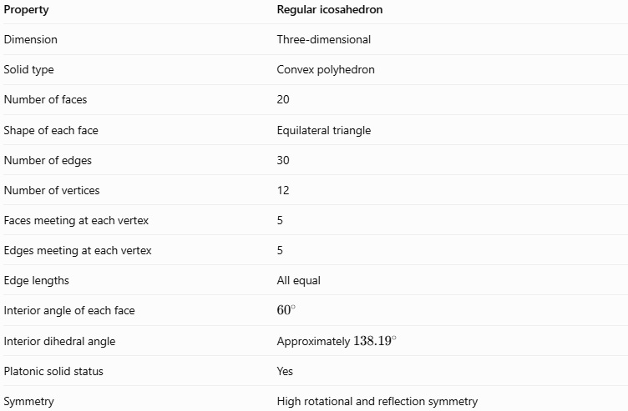
Property | Regular icosahedron
Dimension | Three-dimensional
Solid type | Convex polyhedron
Number of faces | 20
Shape of each face | Equilateral triangle
Number of edges | 30
Number of vertices | 12
Faces meeting at each vertex | 5
Edges meeting at each vertex | 5
Edge lengths | All equal
Interior angle of each face | $${60}^{∘}$$
Interior dihedral angle | Approximately ${138.19}^{∘}$
Platonic solid status | Yes
Symmetry | High rotational and reflection symmetry

Geometric Representation
# Source: AI Source: Provided by: [Data Path: Persons Table -> ID Column: 1, Name_En Column: Motasem Essam] -> From: [ChatGPT] on [7/25/2026]
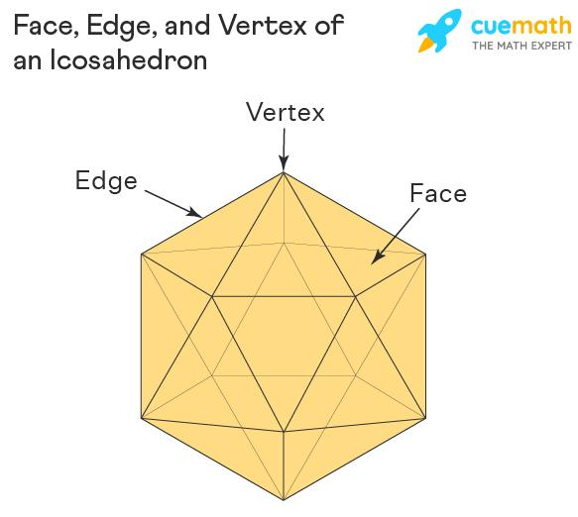
Faces
The regular icosahedron has twenty congruent equilateral-triangle faces. Each face has three equal sides and three ${60}^{∘}$ angles.
Edges
Each triangular face has three edges. Counting the edges of all faces gives:
$$20×3=60$$
Since every physical edge belongs to two faces:
$$E=\frac{60}{2}=30$$
Vertices
The solid has twelve vertices. Five triangular faces and five edges meet at each vertex.
Counting the triangle corners gives $20×3=60$ face-vertex incidences. Each physical vertex belongs to five faces, so:
$$V_{e}=\frac{60}{5}=12$$
Overall structure
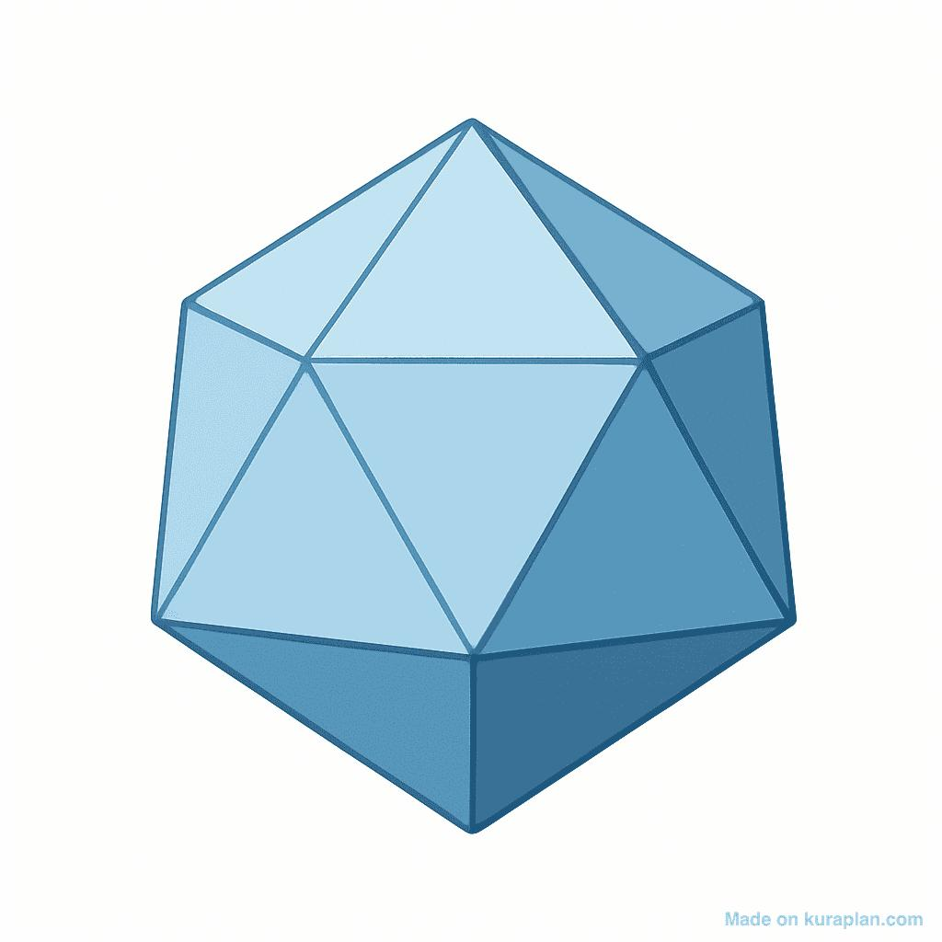
The icosahedron has many triangular faces distributed around its surface, creating a shape that is closer to a sphere than the tetrahedron, cube, or octahedron in terms of its overall appearance.

Mathematical Representations and Formulas
# Source: AI Source: Provided by: [Data Path: Persons Table -> ID Column: 1, Name_En Column: Motasem Essam] -> From: [ChatGPT] on [7/25/2026]
Let:
- $a$ = edge length
- $A_{f}$ = area of one triangular face
- $A_{T}$ = total surface area
- $V$ = volume
- $φ$ = golden ratio
The golden ratio is:
$$φ=\frac{1+\sqrt{5}}{2}≈1.618$$

Number of faces, edges, and vertices
# Source: AI Source: Provided by: [Data Path: Persons Table -> ID Column: 1, Name_En Column: Motasem Essam] -> From: [ChatGPT] on [7/25/2026]
For a regular icosahedron:
$$F=20, E=30, V_{e}=12$$
Euler's formula for convex polyhedra is:
$$V_{e}-E+F=2$$
Substituting:
$$12-30+20=2$$
Therefore, the icosahedron satisfies Euler's formula.

Area of one face
# Source: AI Source: Provided by: [Data Path: Persons Table -> ID Column: 1, Name_En Column: Motasem Essam] -> From: [ChatGPT] on [7/25/2026]
Each face is an equilateral triangle:
$$\boxed{A_{f}=\frac{\sqrt{3}}{4}a^{2}}$$

Total surface area
# Source: AI Source: Provided by: [Data Path: Persons Table -> ID Column: 1, Name_En Column: Motasem Essam] -> From: [ChatGPT] on [7/25/2026]
The regular icosahedron has twenty congruent triangular faces:
$$A_{T}=20A_{f}$$
Therefore:
$$\boxed{A_{T}=5\sqrt{3}a^{2}}$$

Volume
# Source: AI Source: Provided by: [Data Path: Persons Table -> ID Column: 1, Name_En Column: Motasem Essam] -> From: [ChatGPT] on [7/25/2026]
The volume of a regular icosahedron is:
$$\boxed{V=\frac{5\left(3+\sqrt{5}\right)}{12}a^{3}}$$
Approximately:
$$\boxed{V≈2.18169a^{3}}$$

Circumradius
# Source: AI Source: Provided by: [Data Path: Persons Table -> ID Column: 1, Name_En Column: Motasem Essam] -> From: [ChatGPT] on [7/25/2026]
The circumradius is the distance from the center of the solid to any vertex:
$$\boxed{R=\frac{a}{4}\sqrt{10+2\sqrt{5}}}$$

Inradius
# Source: AI Source: Provided by: [Data Path: Persons Table -> ID Column: 1, Name_En Column: Motasem Essam] -> From: [ChatGPT] on [7/25/2026]
The inradius is the perpendicular distance from the center to any face:
$$\boxed{r=\frac{\sqrt{3}\left(3+\sqrt{5}\right)}{12}a}$$

Total edge length
# Source: AI Source: Provided by: [Data Path: Persons Table -> ID Column: 1, Name_En Column: Motasem Essam] -> From: [ChatGPT] on [7/25/2026]
Since the solid has thirty equal edges:
$$\boxed{L=30a}$$

Dihedral angle
# Source: AI Source: Provided by: [Data Path: Persons Table -> ID Column: 1, Name_En Column: Motasem Essam] -> From: [ChatGPT] on [7/25/2026]
The interior dihedral angle is the angle between two adjacent triangular faces, measured inside the solid.
For a regular icosahedron:
$$\boxed{θ=\cos^{-1}\left(-\frac{\sqrt{5}}{3}\right)}$$
$$θ≈{138.19}^{∘}$$
This is different from the ${60}^{∘}$ interior angle within each triangular face.

Worked Examples
# Source: AI Source: Provided by: [Data Path: Persons Table -> ID Column: 1, Name_En Column: Motasem Essam] -> From: [ChatGPT] on [7/25/2026]
Example 1: Counting geometric elements
Problem: How many faces, edges, and vertices does a regular icosahedron have?
Solution:
- Faces: $F=20$
- Edges: $E=30$
- Vertices: $V_{e}=12$
Check Euler's formula:
$$12-30+20=2$$
Answer: 20 faces, 30 edges, and 12 vertices.
Example 2: Calculating total surface area
Problem: A regular icosahedron has an edge length of $3\text{ cm}$. Find its total surface area.
Formula:
$$A_{T}=5\sqrt{3}a^{2}$$
Substitute $a=3$:
$$A_{T}=5\sqrt{3}{\left(3\right)}^{2}$$
$$A_{T}=45\sqrt{3}$$
Answer:
$$\boxed{A_{T}≈77.94{\text{ cm}}^{2}}$$
Example 3: Calculating volume
Problem: Find the volume of a regular icosahedron with edge length $2\text{ cm}$.
Formula:
$$V=\frac{5\left(3+\sqrt{5}\right)}{12}a^{3}$$
Substitute $a=2$:
$$V=\frac{5\left(3+\sqrt{5}\right)}{12}\left(8\right)$$
$$V=\frac{10}{3}\left(3+\sqrt{5}\right)$$
Answer:
$$\boxed{V≈17.45{\text{ cm}}^{3}}$$
Example 4: Finding the total edge length
Problem: Each edge of a regular icosahedron is $4\text{ cm}$ long. Find the sum of all edge lengths.
Formula:
$$L=30a$$
Substitute:
$$L=30\left(4\right)$$
Answer:
$$\boxed{L=120\text{ cm}}$$
Example 5: Calculating the circumradius
Problem: Find the circumradius of a regular icosahedron with edge length $2\text{ cm}$.
Formula:
$$R=\frac{a}{4}\sqrt{10+2\sqrt{5}}$$
Substitute $a=2$:
$$R=\frac{1}{2}\sqrt{10+2\sqrt{5}}$$
Answer:
$$\boxed{R≈1.90\text{ cm}}$$

Comparison with Related Geometric Solids
# Source: AI Source: Provided by: [Data Path: Persons Table -> ID Column: 1, Name_En Column: Motasem Essam] -> From: [ChatGPT] on [7/25/2026]
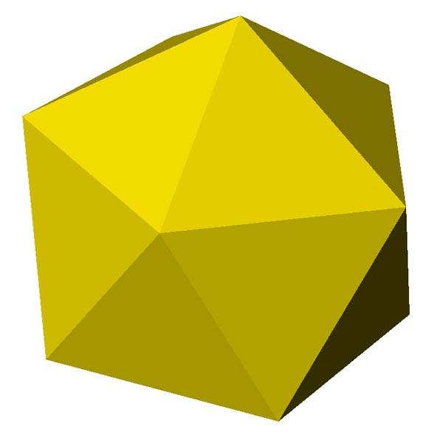
Icosahedron
20 faces · 30 edges · 12 vertices
Has twenty equilateral-triangle faces, with five faces meeting at each vertex.
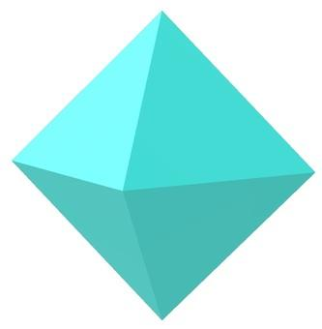
Octahedron
8 faces · 12 edges · 6 vertices
Also has equilateral-triangle faces, but only four faces meet at each vertex.
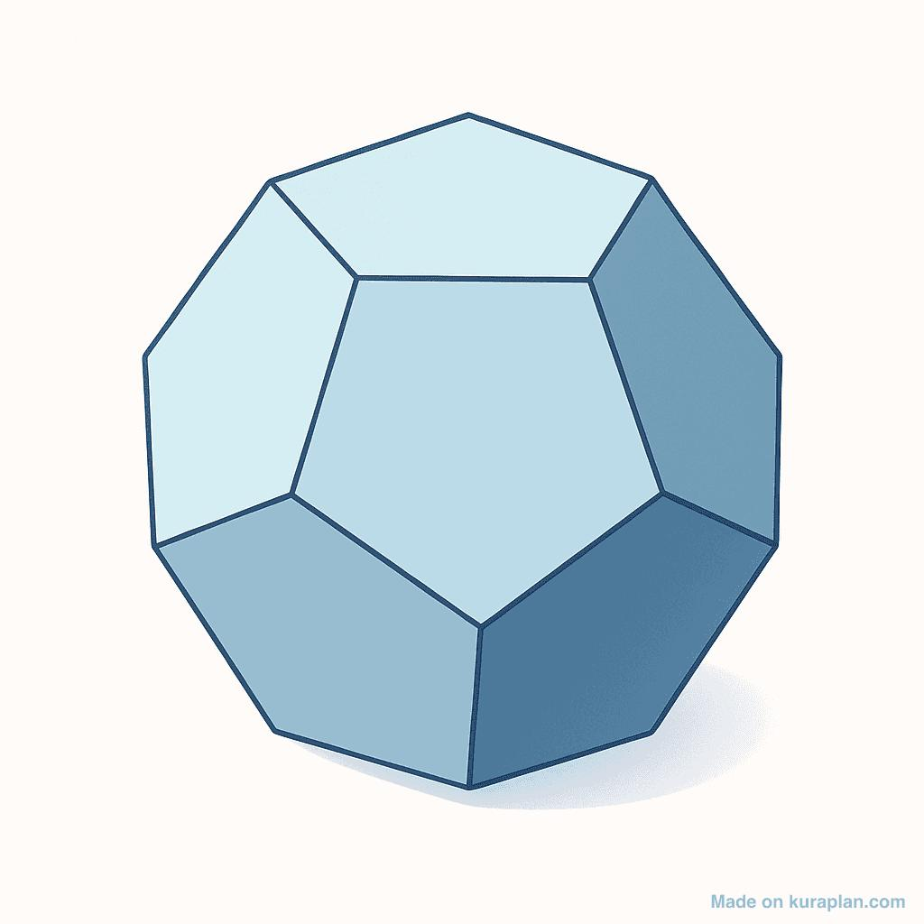
Dodecahedron
12 faces · 30 edges · 20 vertices
Has twelve regular pentagonal faces and is the dual Platonic solid of the icosahedron.
The icosahedron and dodecahedron are dual polyhedra. The icosahedron's twenty faces correspond to the dodecahedron's twenty vertices, while the icosahedron's twelve vertices correspond to the dodecahedron's twelve faces. Both solids have thirty edges.

The Icosahedron Among the Five Platonic Solids
# Source: AI Source: Provided by: [Data Path: Persons Table -> ID Column: 1, Name_En Column: Motasem Essam] -> From: [ChatGPT] on [7/25/2026]
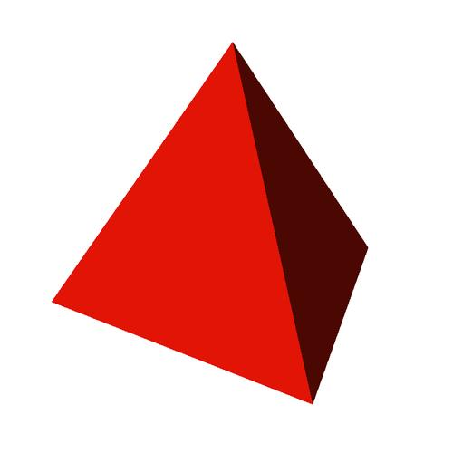
1. Tetrahedron
4 triangular faces
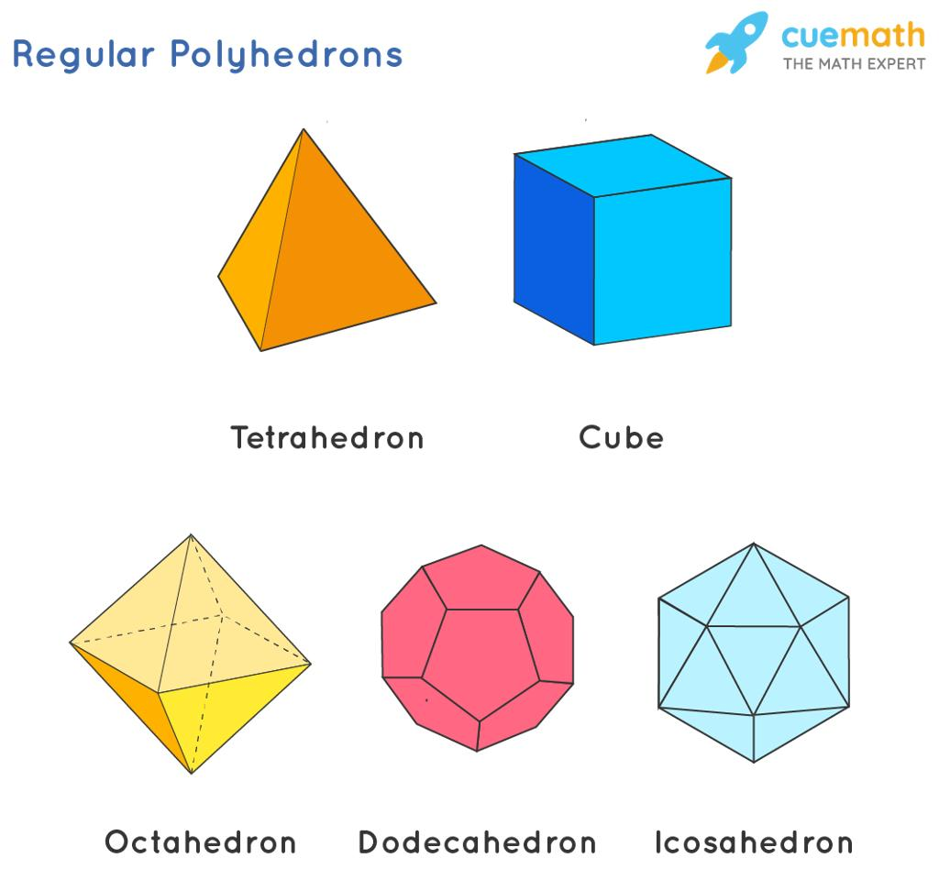
2. Cube (Hexahedron)
6 square faces
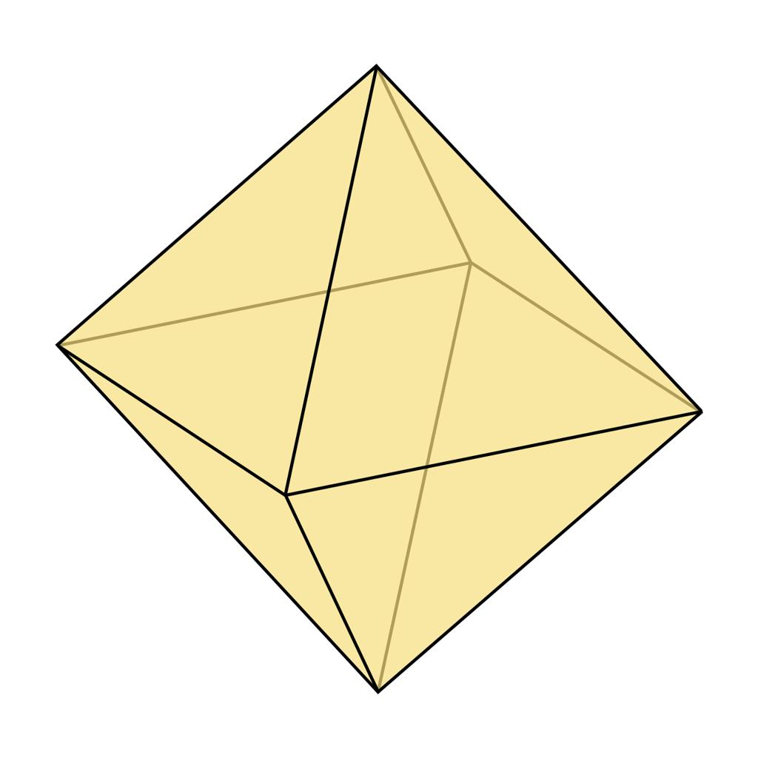
3. Octahedron
8 triangular faces
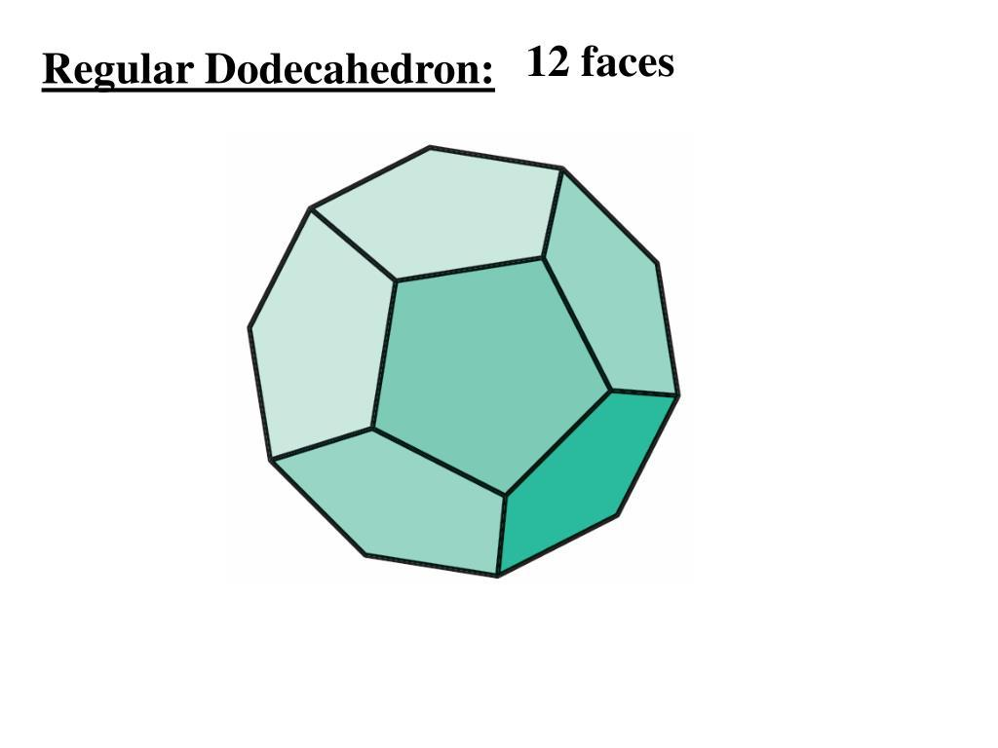
4. Dodecahedron
12 pentagonal faces
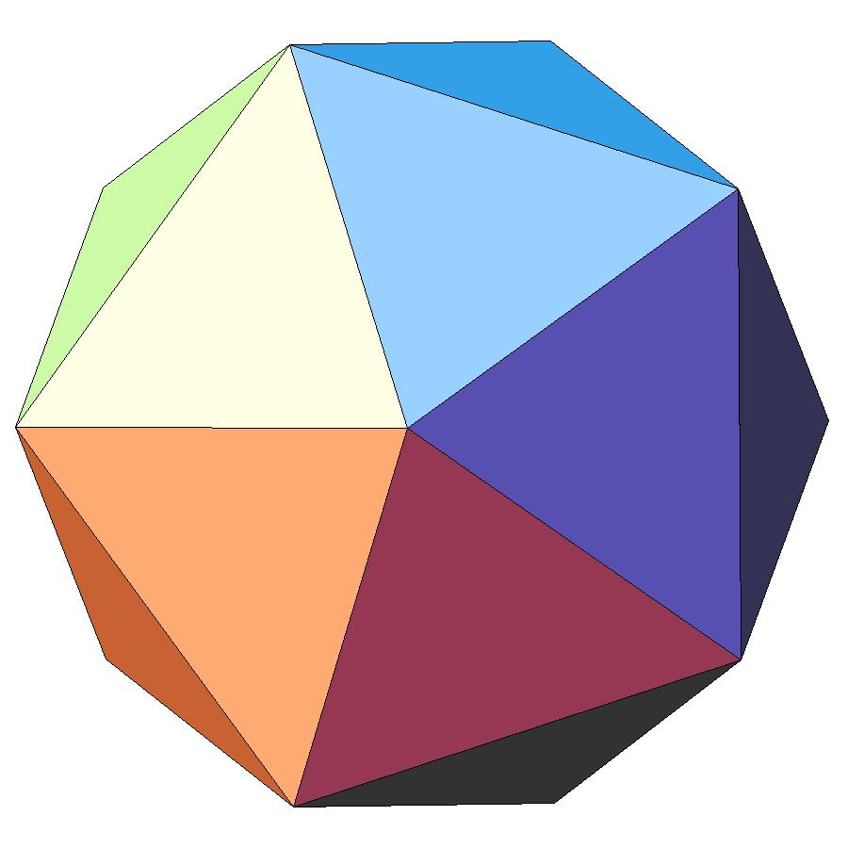
5. Icosahedron
20 triangular faces
The icosahedron has the greatest number of faces among the five Platonic solids. It also has the largest number of edges, tied with the dodecahedron at thirty.

Constructing Icosahedron in Solid Geometry

Instruments Used
# Source: AI Source: Provided by: [Data Path: Persons Table -> ID Column: 1, Name_En Column: Motasem Essam] -> From: [ChatGPT] on [7/25/2026]
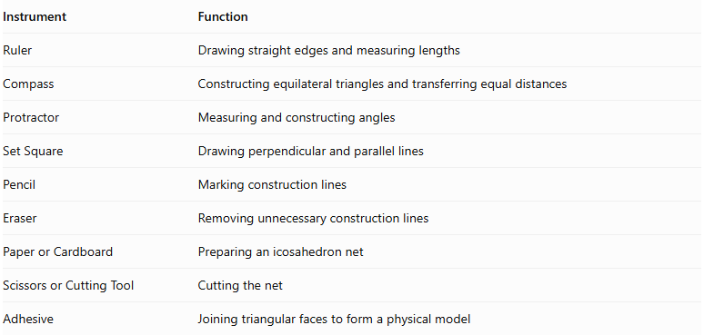
Instrument | Function
Ruler | Drawing straight edges and measuring lengths
Compass | Constructing equilateral triangles and transferring equal distances
Protractor | Measuring and constructing angles
Set Square | Drawing perpendicular and parallel lines
Pencil | Marking construction lines
Eraser | Removing unnecessary construction lines
Paper or Cardboard | Preparing an icosahedron net
Scissors or Cutting Tool | Cutting the net
Adhesive | Joining triangular faces to form a physical model

Construction Procedures

A. Face-Based Construction
# Source: AI Source: Provided by: [Data Path: Persons Table -> ID Column: 1, Name_En Column: Motasem Essam] -> From: [ChatGPT] on [7/25/2026]
- Construct an equilateral triangle using a ruler and compass.
- Determine the required edge length.
- Construct twenty congruent equilateral triangular faces.
- Arrange the triangles according to the adjacency structure of a regular icosahedron.
- Connect corresponding edges of neighboring triangles.
- Ensure that five triangular faces meet at every vertex.
- Complete the solid and distinguish visible edges from hidden edges.
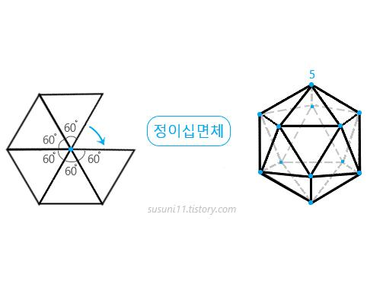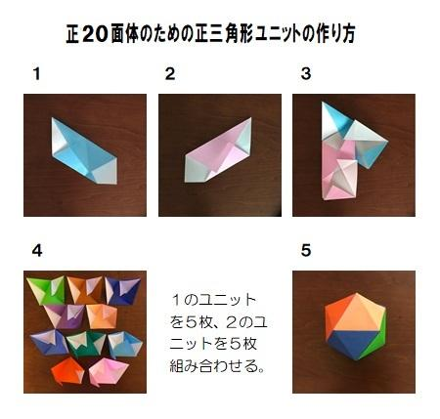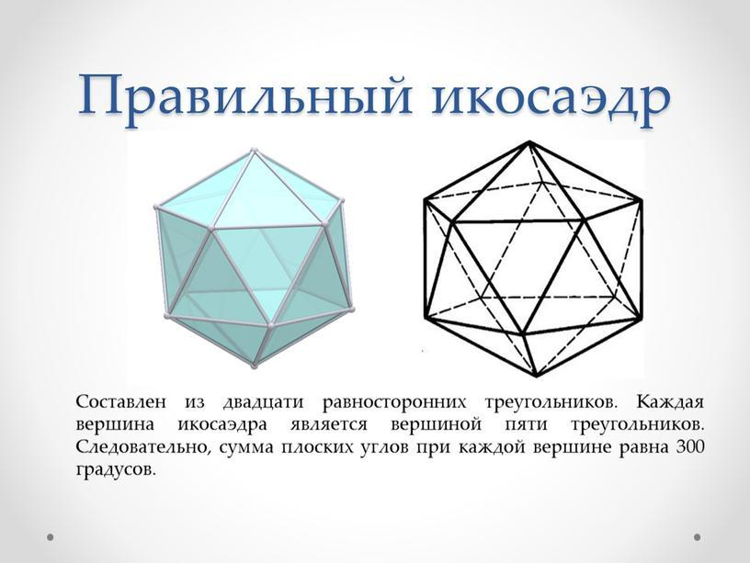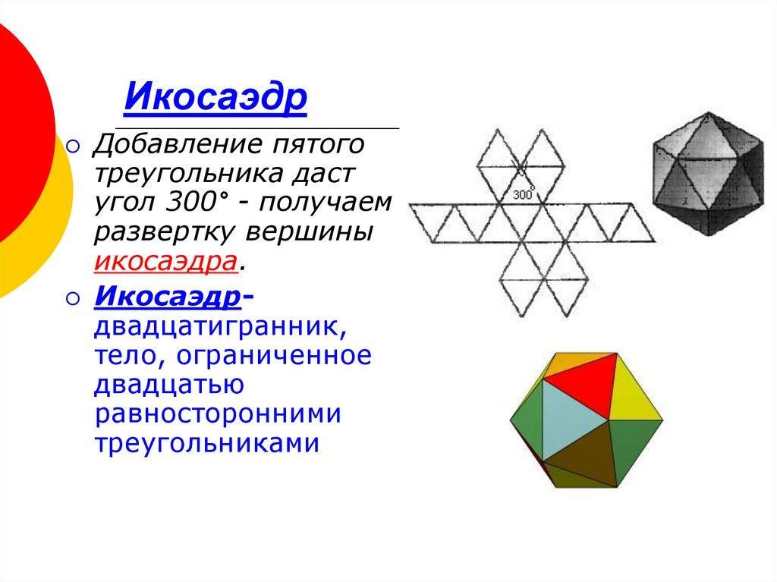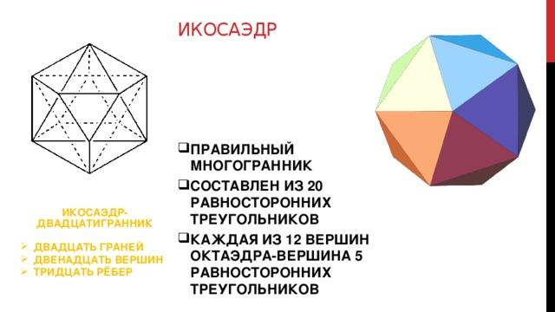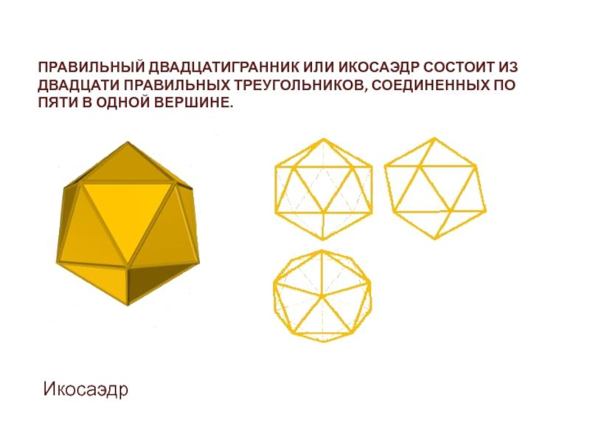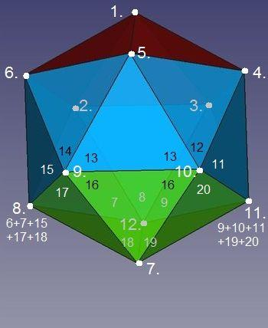

B. Edge-Based Construction
# Source: AI Source: Provided by: [Data Path: Persons Table -> ID Column: 1, Name_En Column: Motasem Essam] -> From: [ChatGPT] on [7/25/2026]
- Determine the required edge length.
- Construct thirty equal-length edges.
- Arrange the edges according to the icosahedron's triangular face structure.
- Form twenty closed triangular boundaries.
- Connect the triangular faces along their shared edges.
- Verify that each edge belongs to exactly two faces.
- Check that five edges meet at every vertex.

C. Vertex-Based Construction
# Source: AI Source: Provided by: [Data Path: Persons Table -> ID Column: 1, Name_En Column: Motasem Essam] -> From: [ChatGPT] on [7/25/2026]
- Establish the twelve vertices of the icosahedron using geometric construction relationships.
- Arrange the vertices according to the solid's triangular structure.
- Identify the thirty pairs of adjacent vertices.
- Connect each adjacent pair to form an edge.
- Complete the twenty triangular faces.
- Verify that five triangular faces meet at every vertex.

D. Net-Based Construction
# Source: AI Source: Provided by: [Data Path: Persons Table -> ID Column: 1, Name_En Column: Motasem Essam] -> From: [ChatGPT] on [7/25/2026]
- Draw twenty congruent equilateral triangles.
- Arrange the triangles into a valid connected icosahedron net.
- Ensure that each triangle is connected to its neighboring faces along complete edges.
- Add joining tabs if preparing a physical model.
- Cut out the net.
- Fold along the shared edges.
- Join the corresponding edges to form the closed icosahedron.
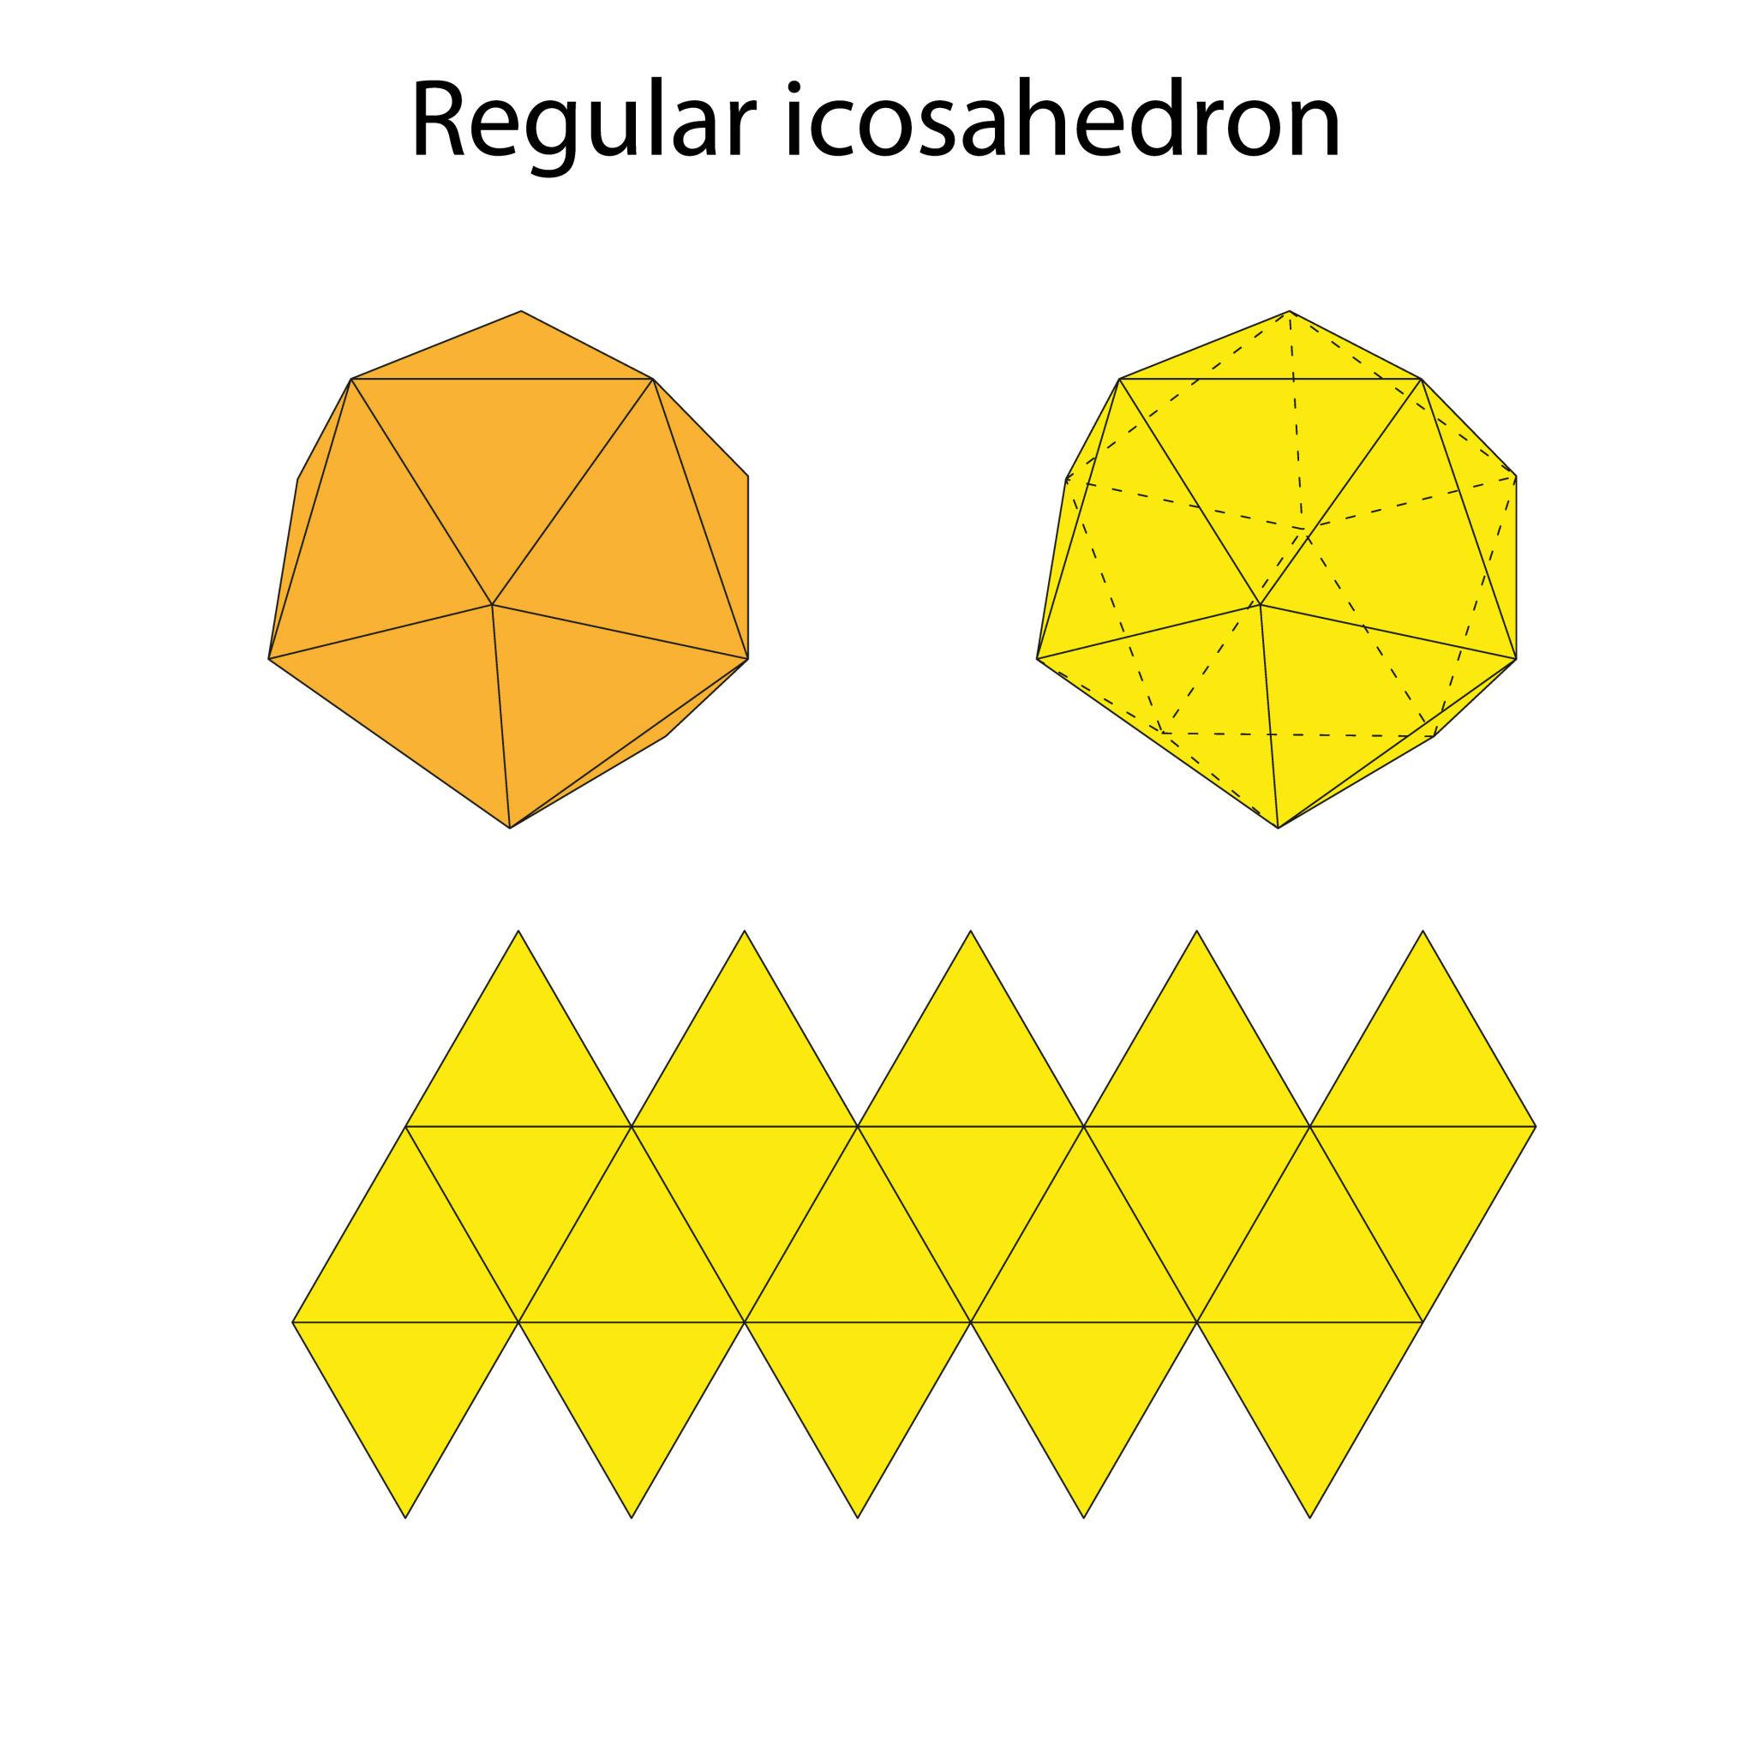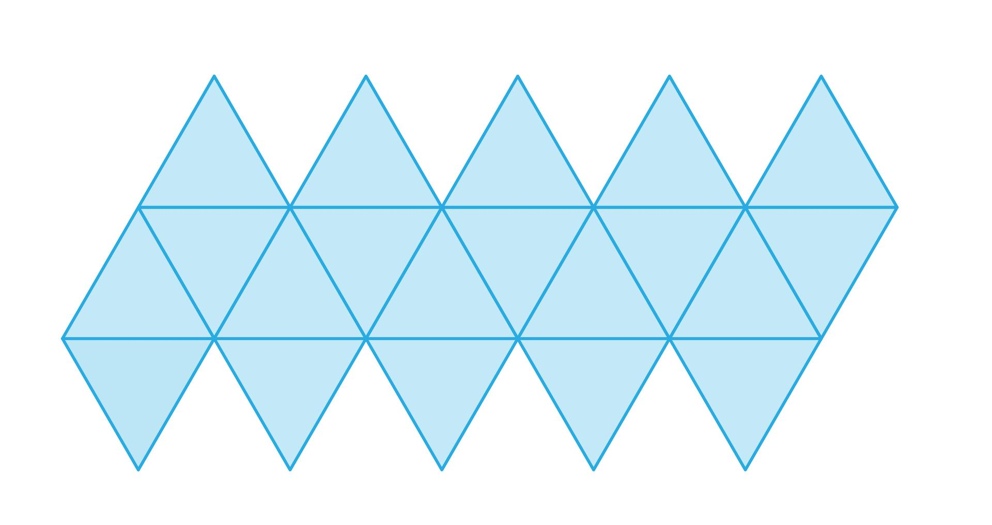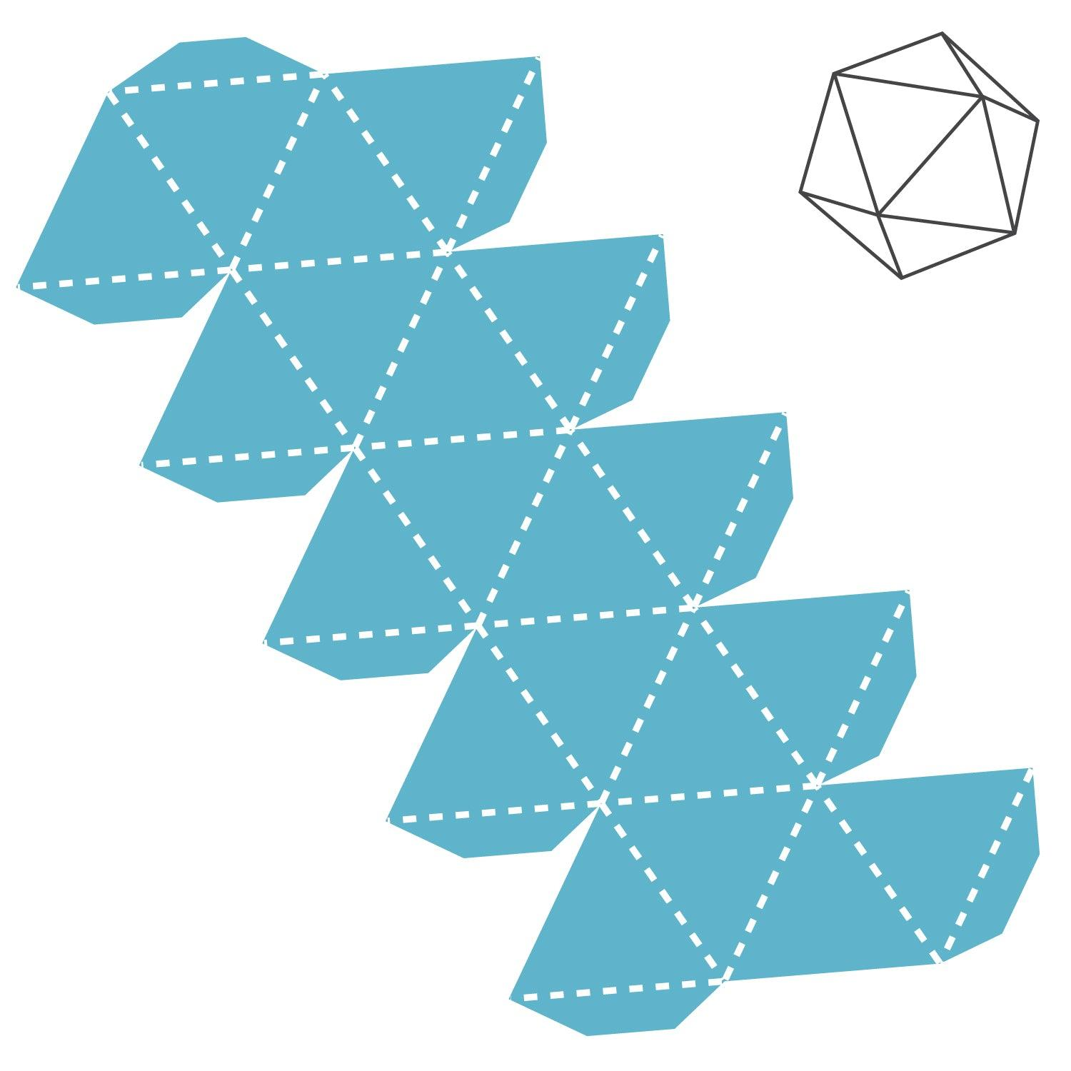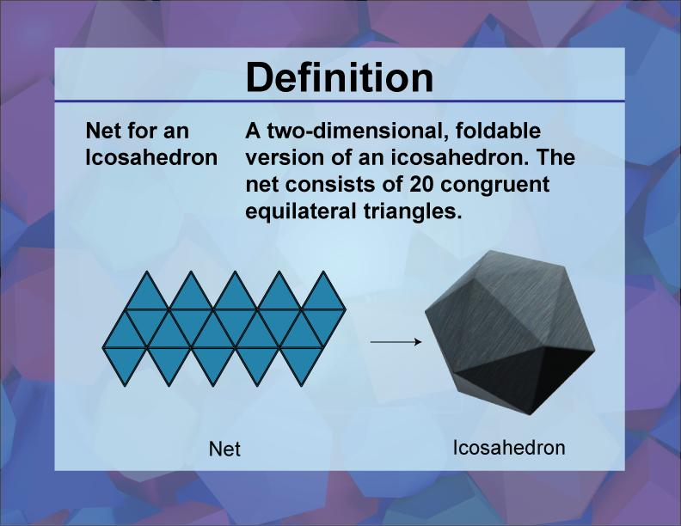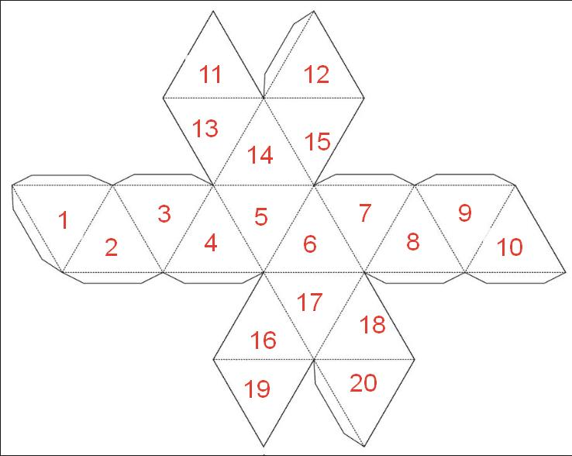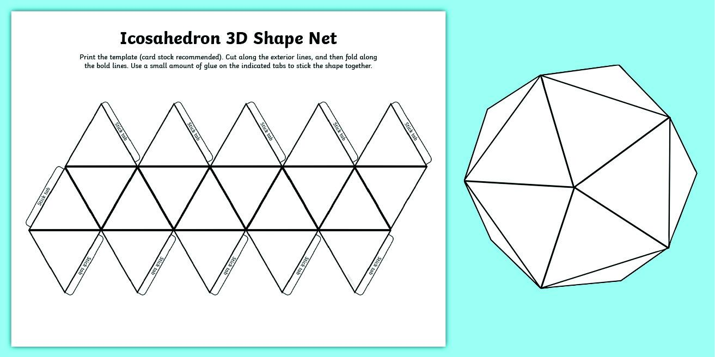

E. Physical Model Construction
# Source: AI Source: Provided by: [Data Path: Persons Table -> ID Column: 1, Name_En Column: Motasem Essam] -> From: [ChatGPT] on [7/25/2026]
- Prepare twenty congruent equilateral triangular pieces or a suitable icosahedron net.
- Measure and cut all triangular pieces to equal dimensions.
- Arrange the triangular faces according to the icosahedron structure.
- Join neighboring faces along their corresponding edges.
- Close the solid by connecting the remaining open edges.
- Verify that the completed model has twenty faces, thirty edges, and twelve vertices.

Applications of the Icosahedron
# Source: AI Source: Provided by: [Data Path: Persons Table -> ID Column: 1, Name_En Column: Motasem Essam] -> From: [ChatGPT] on [7/25/2026]
- Gaming: the familiar twenty-sided die, or D20, is shaped like a regular icosahedron.
- Virology: some viruses have capsids with icosahedral symmetry, allowing a complex structure to be built from repeated protein units.
- Computer graphics: icosahedra can be subdivided to create approximately spherical meshes.
- Geodesic structures: subdivided icosahedral forms are used to create dome-like structures and spherical approximations.
- Mathematics education: illustrates symmetry, triangular meshes, Euler's formula, and dual polyhedra.
- Scientific modeling: useful in computational geometry and simulations involving symmetrical three-dimensional forms.

Key Points
# Source: AI Source: Provided by: [Data Path: Persons Table -> ID Column: 1, Name_En Column: Motasem Essam] -> From: [ChatGPT] on [7/25/2026]
- An icosahedron is a polyhedron with twenty faces.
- The regular icosahedron is one of the five Platonic solids.
- It has 20 equilateral-triangle faces, 30 equal edges, and 12 vertices.
- Five faces and five edges meet at each vertex.
- Total surface area: $A_{T}=5\sqrt{3}a^{2}$.
- Volume: $V=\frac{5\left(3+\sqrt{5}\right)}{12}a^{3}$.
- Circumradius: $R=\frac{a}{4}\sqrt{10+2\sqrt{5}}$.
- Its dual Platonic solid is the dodecahedron.
- It satisfies Euler's formula: $V_{e}-E+F=2$.

Conclusion
# Source: AI Source: Provided by: [Data Path: Persons Table -> ID Column: 1, Name_En Column: Motasem Essam] -> From: [ChatGPT] on [7/25/2026]
The icosahedron is one of the five Platonic solids and is distinguished by its twenty congruent equilateral-triangle faces. Its thirty equal edges, twelve vertices, and five faces meeting at every vertex create a highly symmetrical three-dimensional structure. Its applications in gaming, virology, computer graphics, and geometric modeling demonstrate the importance of this solid beyond pure mathematics.

